Currency Task

At first, the page displays only the dropdown button named: „Choose a currency “



In the solve function, there are two constants selected from the HTML named „title “and „main “. Then three sections are created representing the three groups. There is a helper function “e” which helps to create new tags.

There are also “ul” tags appended to the sections.

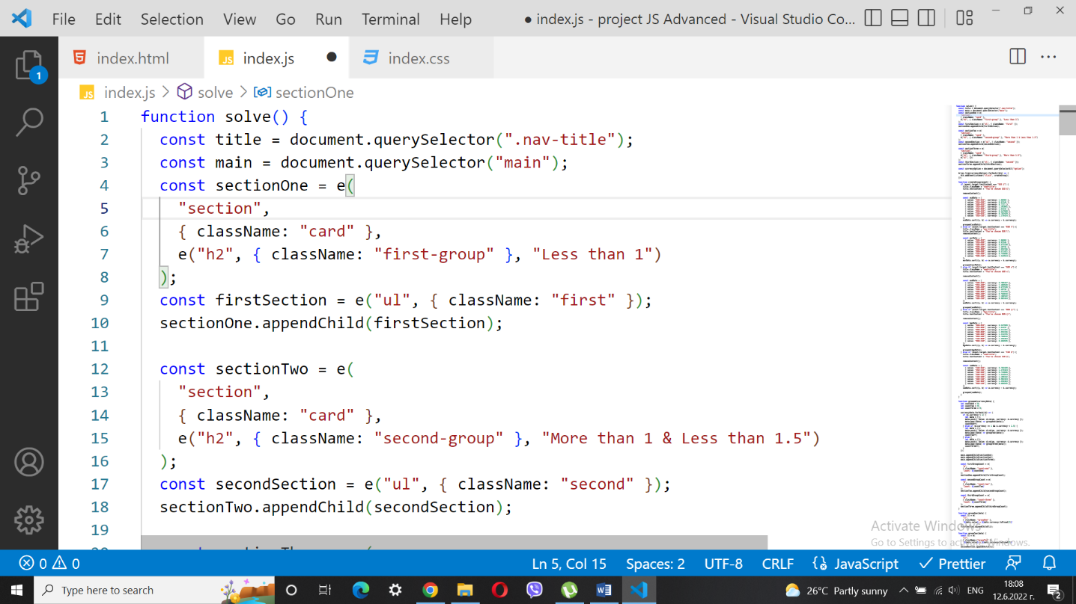

A constant is created for the options and then they are transformed into an array. “forEach” is used to listen to the current option:

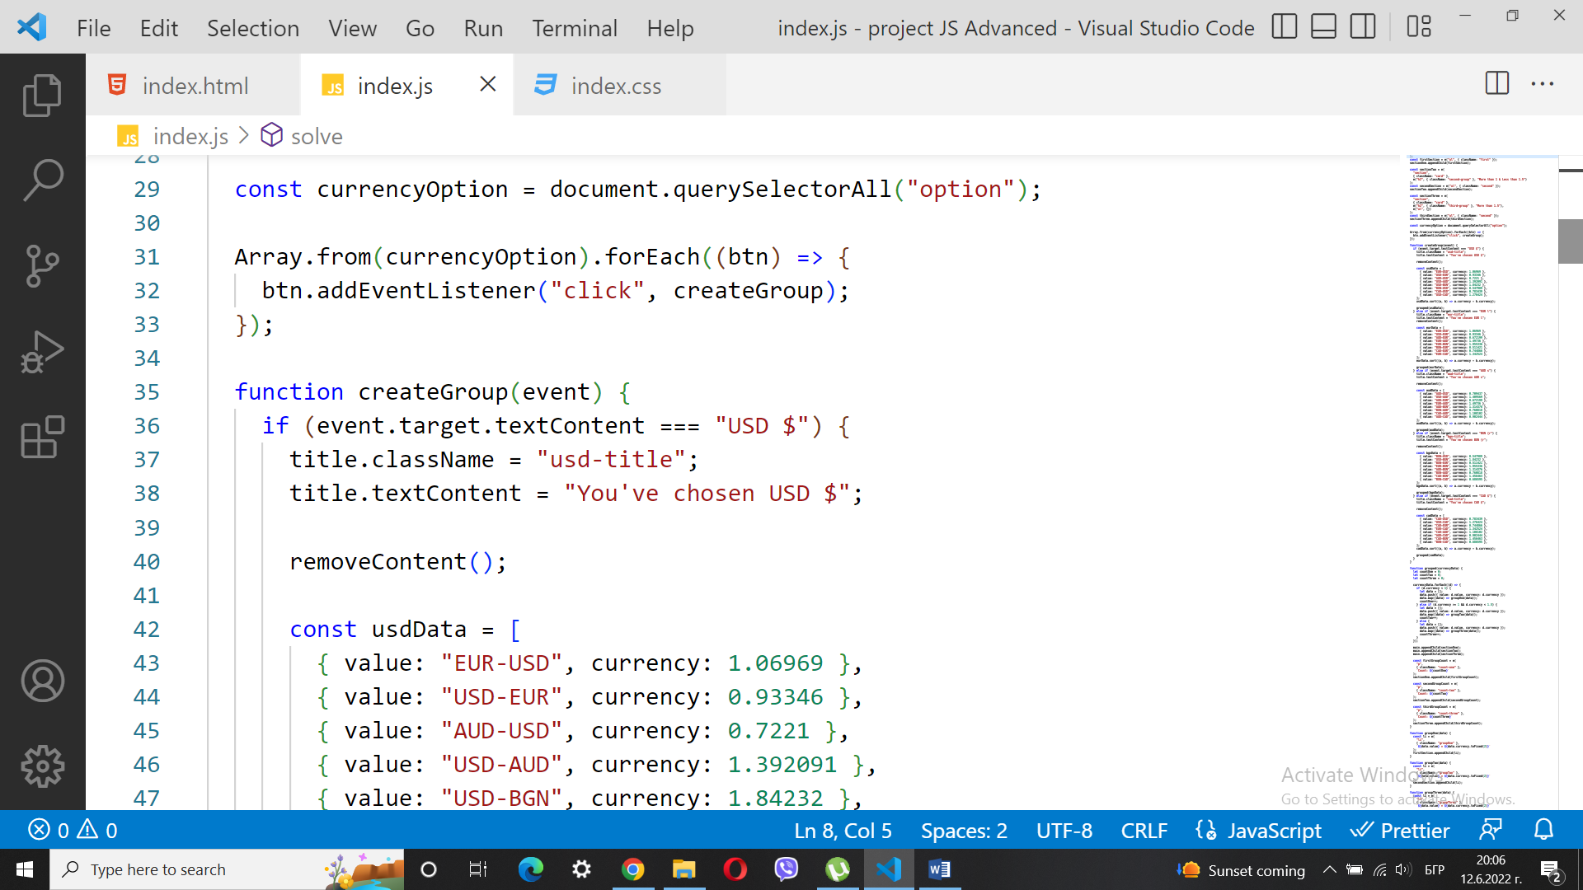

The function createGroup checks which option is selected. The class and the name of the title are also changed.

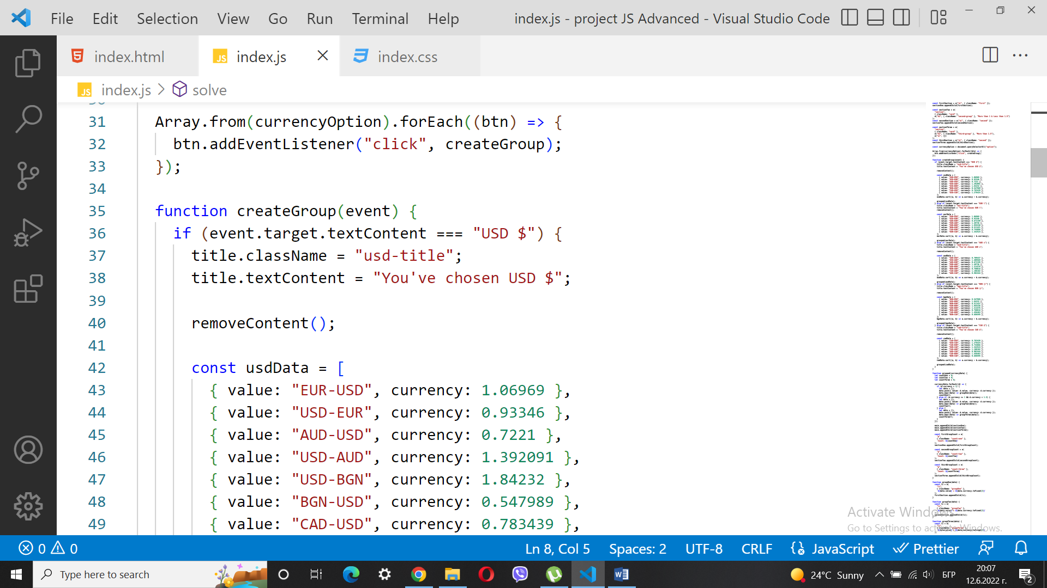

On the page should be displayed the title of chosen currency.

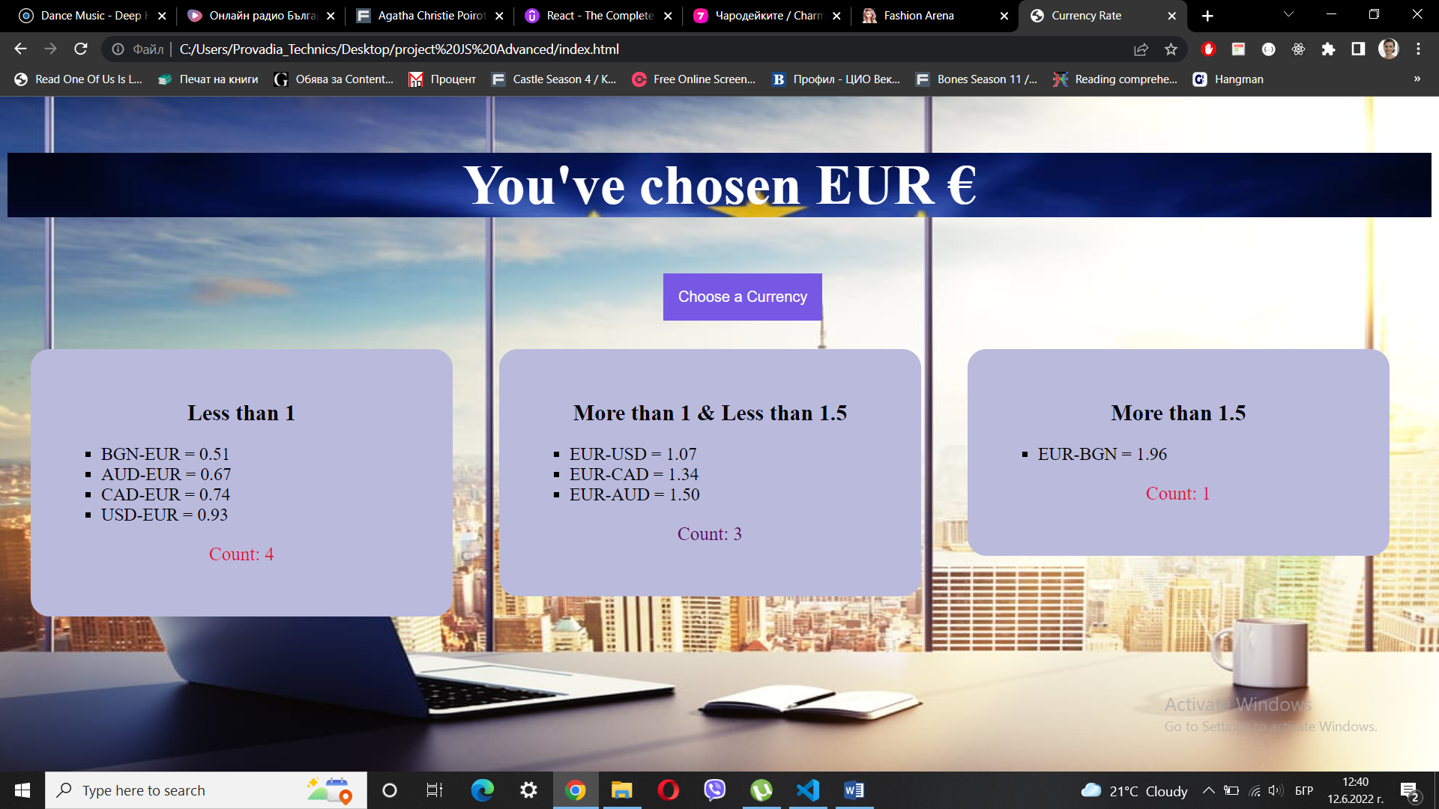

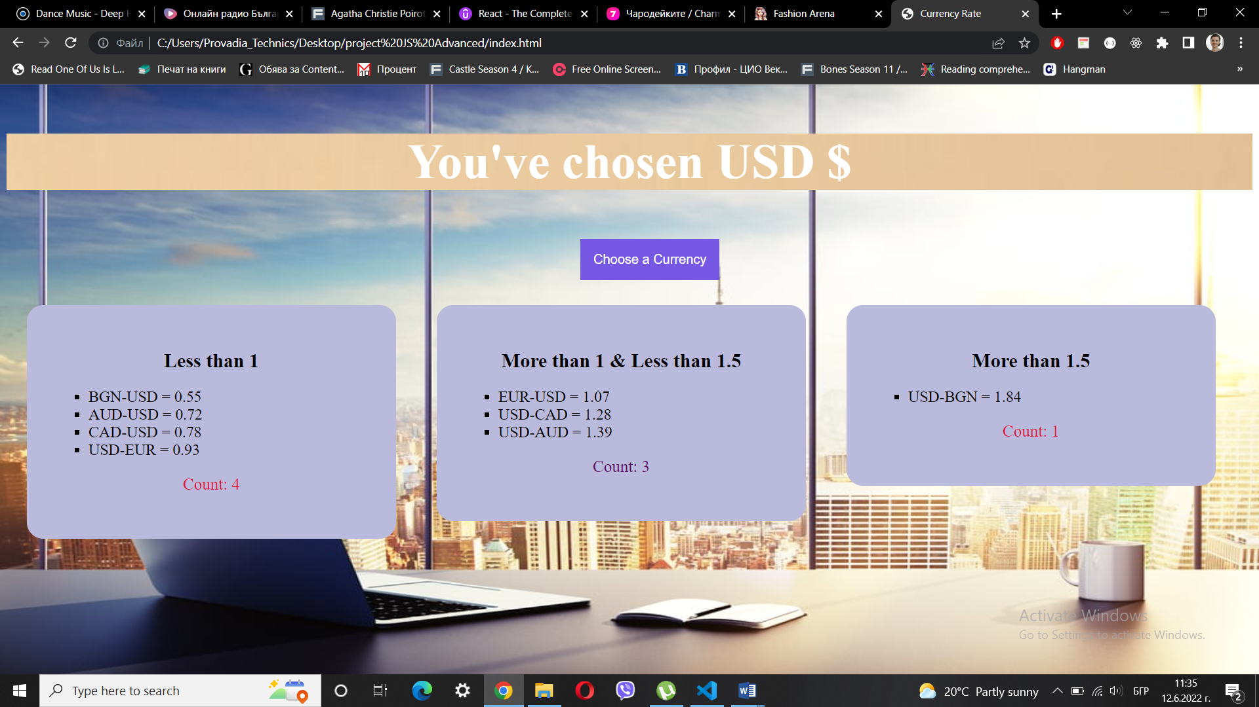

Upon creation of the title the removeContent function is called, it clears the currently displayed exchange rates.

Each currency has an object of arrays:

const usdData = [{ value: "EUR-USD", currency: 1.06969 }]

Then the array is sorted.

usdData.sort((a, b) => a.currency - b.currency);

Sorted data is sent to a grouping function:

grouped(usdData);

The grouping function has three variables equal to zero. These variables are going to count the number of items in the corresponding group. Using “forEach” the value is checked and a new array is created, and the array is sent to a function that creates list items.

Bellow the previously created sections are appended to the “main”.

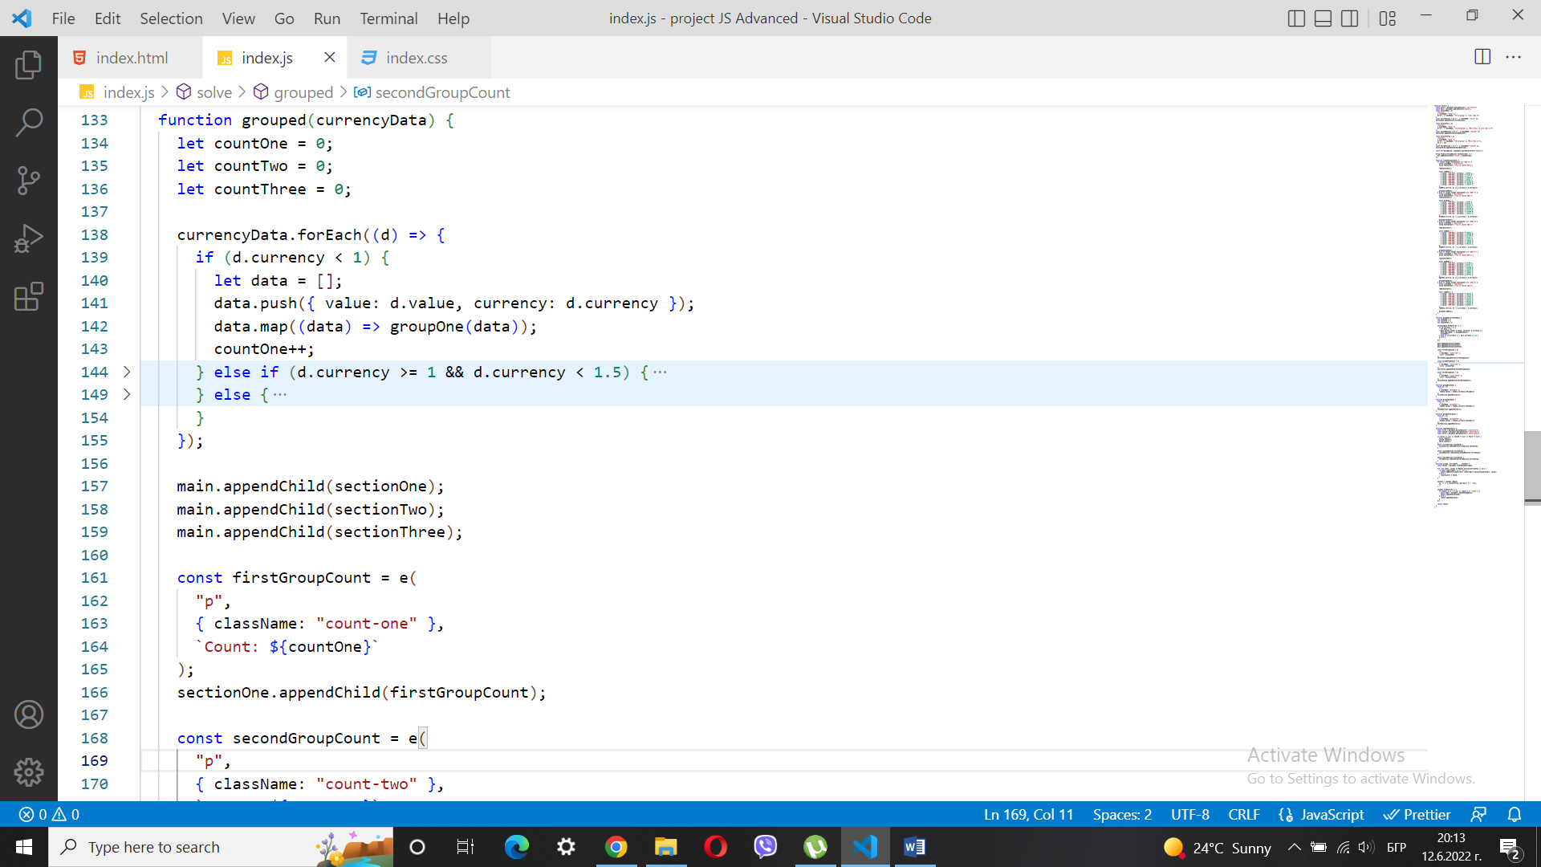

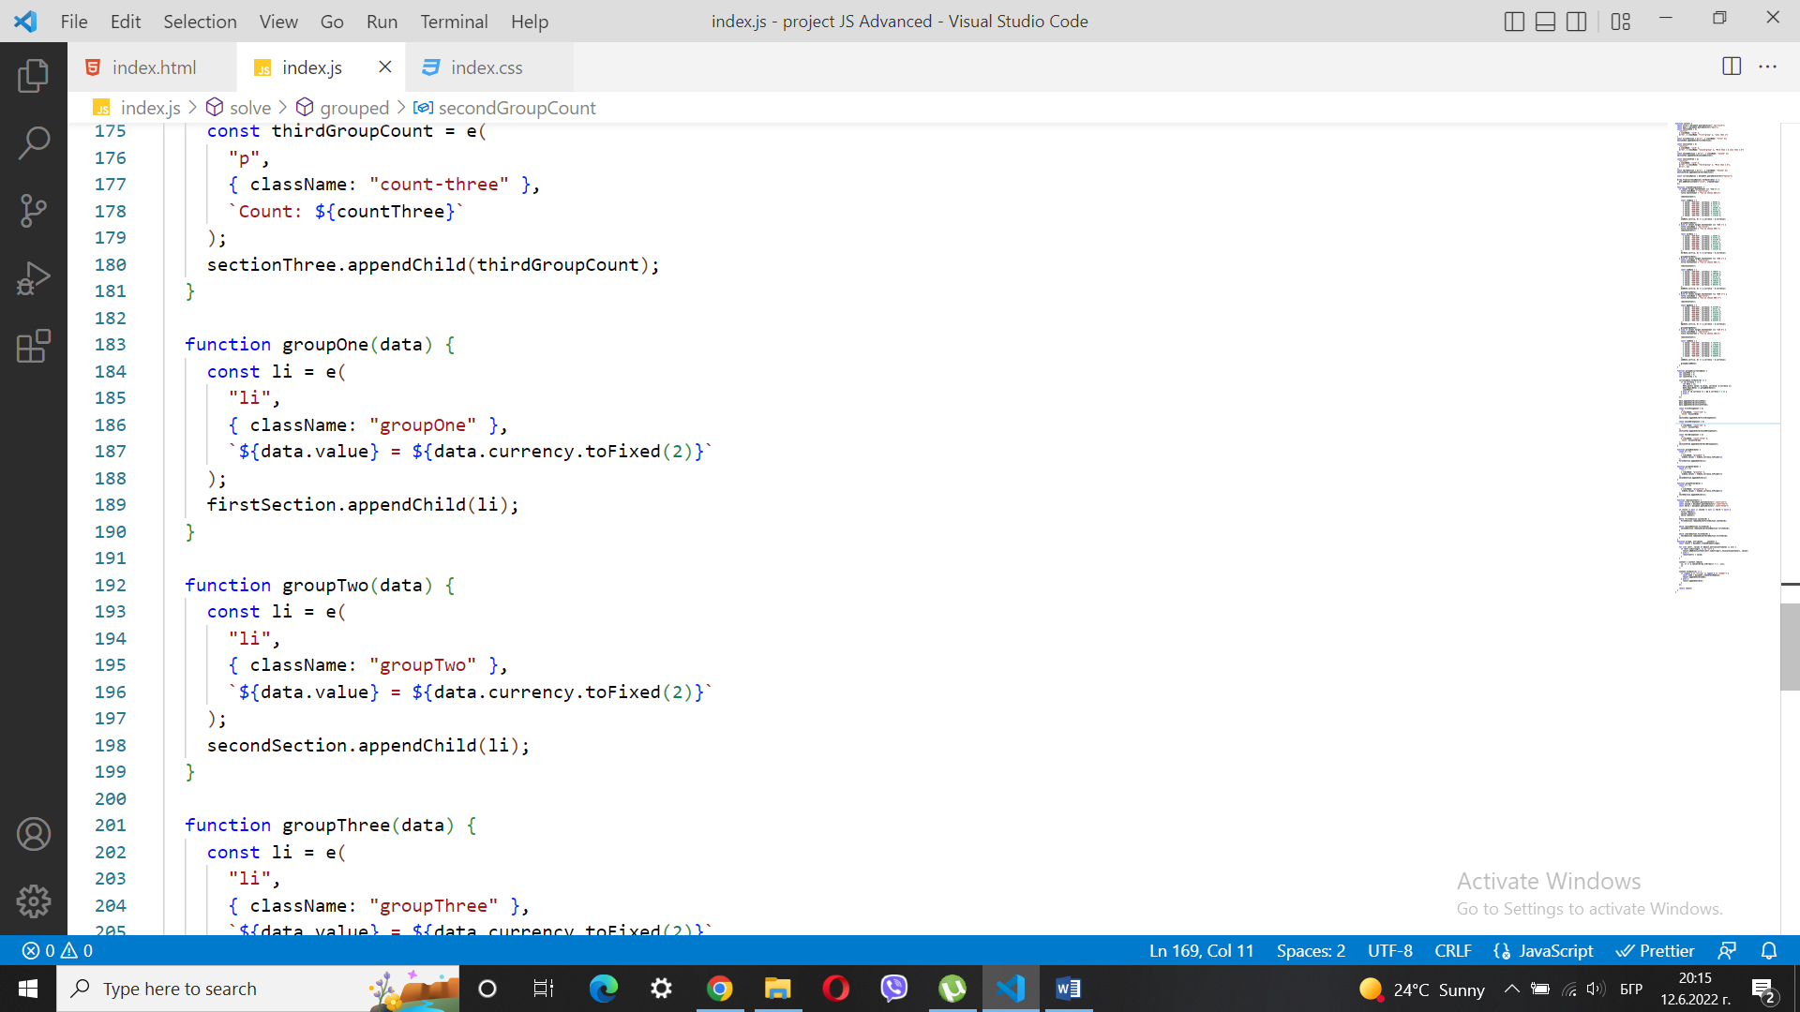

The result should be like this:

